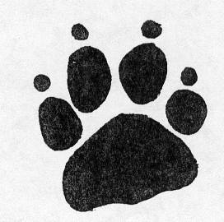
Dear students
of ,

You are invited to become a Teddy Bear Guardian. We know that you all look after your teddy bears very well. What many people do not know is that Teddy Bears once looked after themselves. They lived wild in the forest.

To learn how to be a Teddy Bear Guardian you can come to our forest. Here, we will show you how you can teach your teddies to live in the wild. In the forest they can find all the things they need to live.

You should bring your teddy with you. If you haven’t got a teddy, bring another soft animal friend. Invite your soft animal friend to come on a picnic. When you come on the picnic, you will learn the secret of P.A.W.S.

We look forward to seeing you.

Yours Sincerely,
Matt – Principal of Thalgarrah
Theodore - Teddy in Charge

