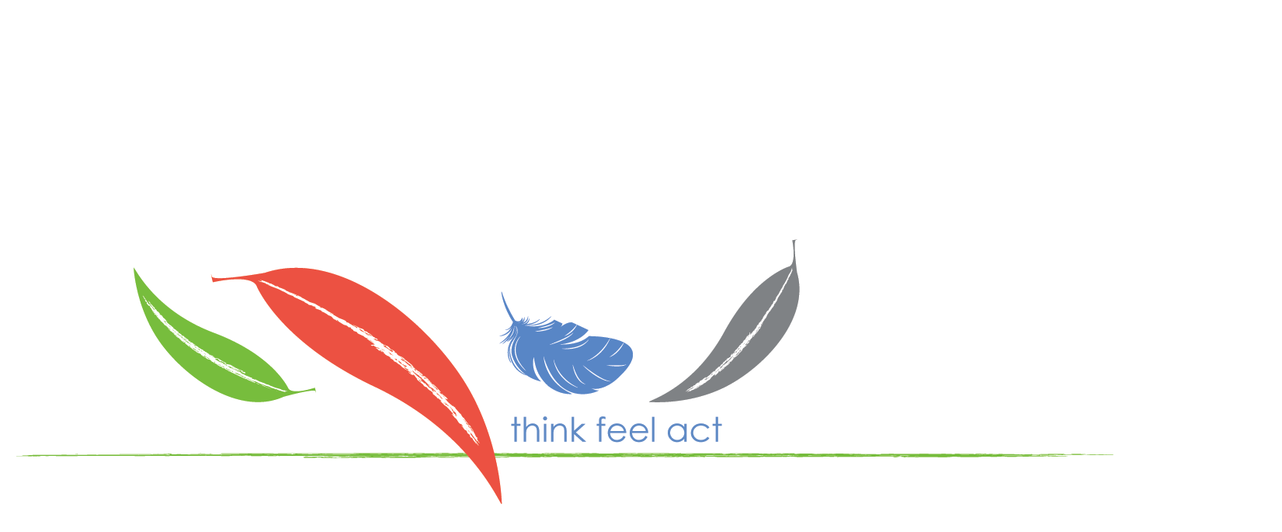
Student Welfare Information

This form must be returned to Thalgarrah prior to your visit by:
Fax: 6775 1681, or
Email: thalgarrah-e.school@det.nsw.edu.au

This information will be used to assist us with the safe management of students whilst at the centre. All information provided will remain confidential.
List students who have the following welfare issues:
- students who have medical conditions such as asthma, diabetes, anaphylaxis, allergies, or other that could be aggravated by activities in our programs.
- students with physical disabilities and/or other special needs e.g. autism, etc.
- students with behaviour concerns.

School: | Teacher: | Date of visit:

Student name | Welfare Issue | Action Plan or X

